## MUAC (Mid-Upper Arm Circumference) indicator and climate data: correlations

* Gifs of MUAC against precipitation and its lags
* Each image of gif presents one lag
* Correlation dies out with increasing lag
* ASAL counties, 2013-2017, monthly data
* MUAC from the NDMA bulletins



* According to correlation coefficients, MUAC and precipitation highly correlated
* Also MUAC and the lags of precipitation highly correlated

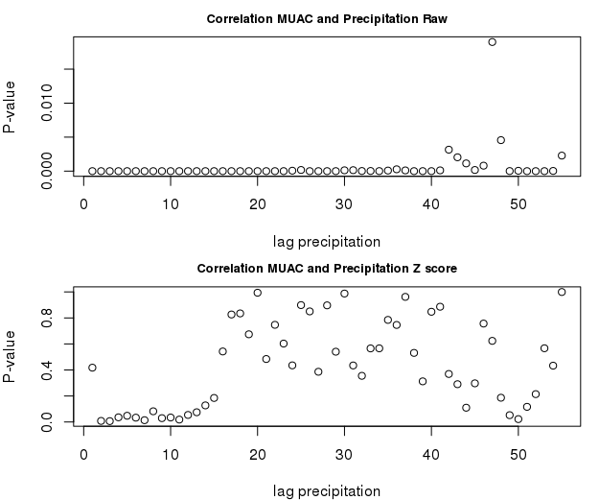

* For the raw precipitation (the upper picture above) , the correlations highly significant for all lags except one
  + This could be due to the county specific effects
* The p- values relatively higher for lag 40 and more
* For the Z score of precipitation, the correlation stops being significant for lags around 10 and more
* **Coping Strategy Index (CSI)- interesting point:** the correlation between CSI and z score of precipitation only starts to be significant at lag 4 of the precipitation.
  + Hence, the coping strategies are only significant after 3 months of drought (in terms of z-score of precipitation)